Grafana Teams Alerts Configuration
Summary:-
We already have the Grafana Dashboard on which we are going to set the Microsoft Teams Alerts.
Which will help to monitor the Up’s & Down’s in the Dashboard. Like CPU Usage & Memory usage.
Configure the Microsoft Teams to Grafana
- For that you need to create the group in which you will receive the Alerts.
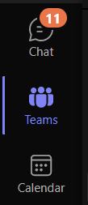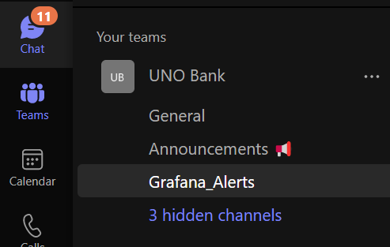
This is Channels.
This is Team, which need to be created.
Open your Teams and click on the “Teams” Icon. If you are authorised to create a Team. The do that if not then ask for it to Administrator.
- After that you have created the Team, then you must create a Channel. As I have created “Grafana_Alerts”.
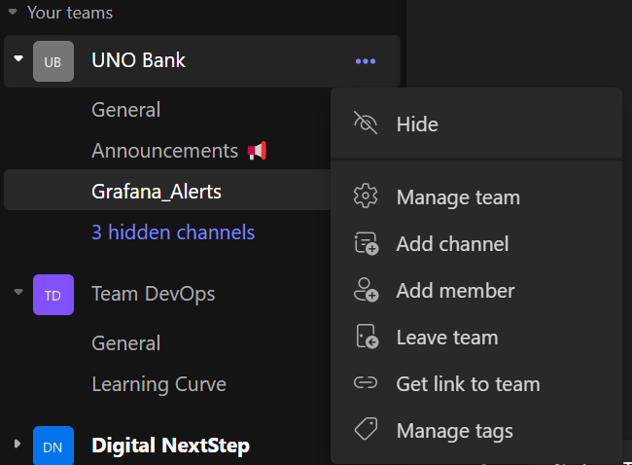
Click on “Add Channel” to create the Channel.
Click on the 3 dots, then you can find the below options.
- After you do the above steps then you see a dialogue box open to create a channel. (Refer below screenshot).
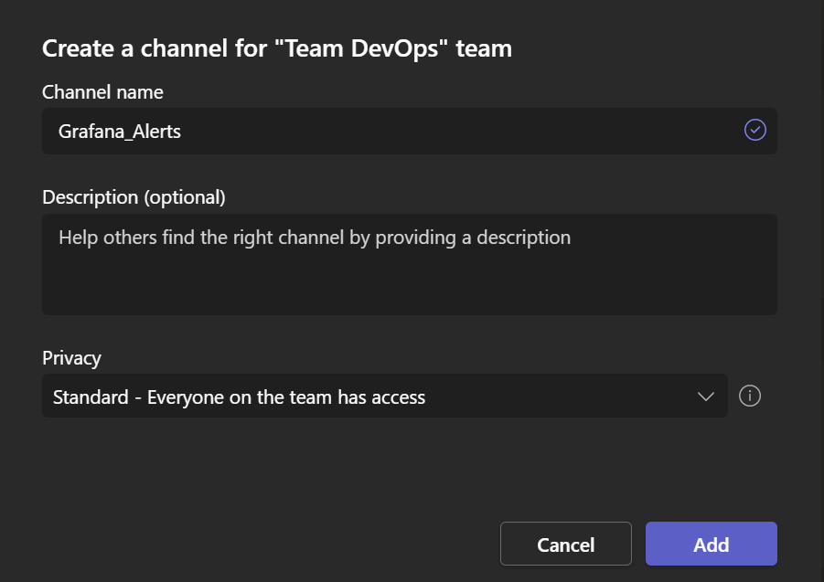
Just give the Name and rest setting will be default.
Click on “ADD”
- After creation of Channel. The we need to connect teams Channel to Grafana.
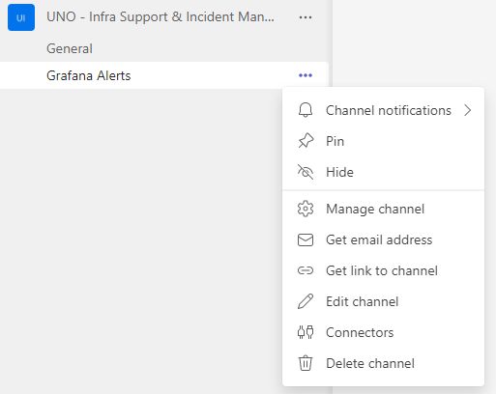
The channel which you created in front of them you will see 3 Dot’s. Click on it and click on “Connectors”.
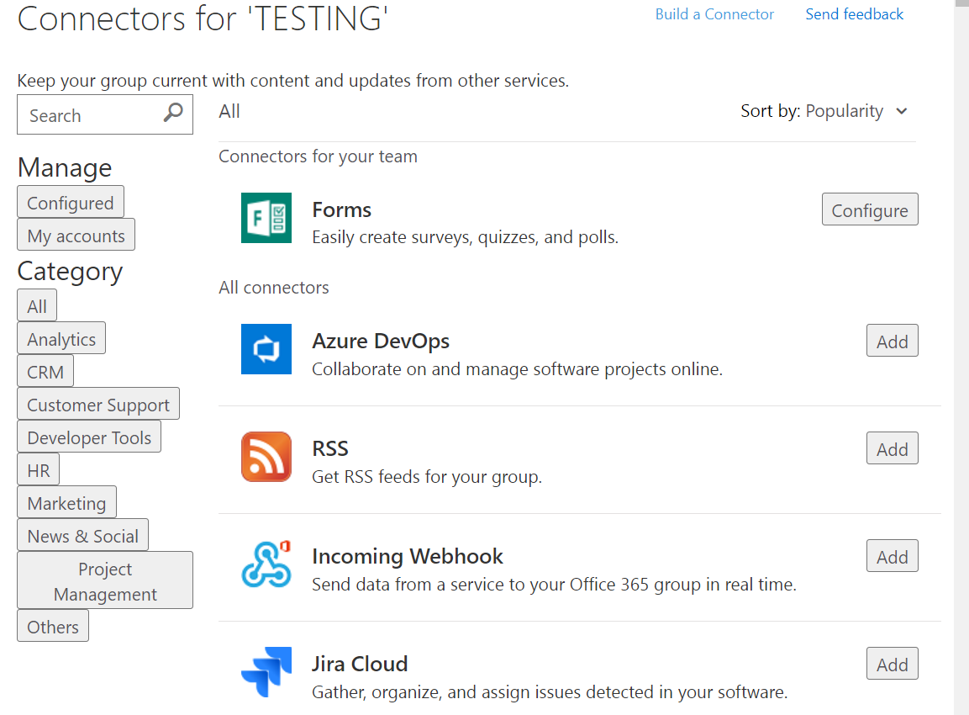
You will see this page, we need to configure the “Incoming Webhook”.
Click on Add. It will reopen a page and then click on Add.
After Adding the page might be disappeared. You need to reopen that page. With the same process as we have done above.

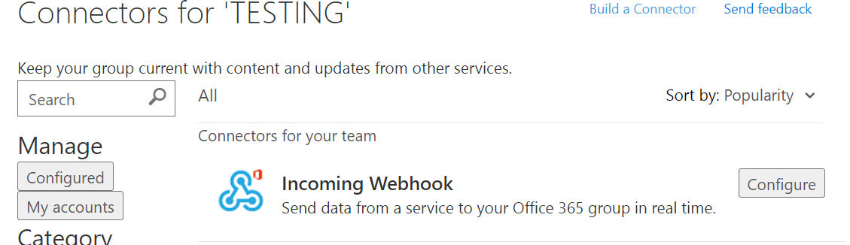
- After you reopen the page, you will see the changes.
- Click on “Configure”.
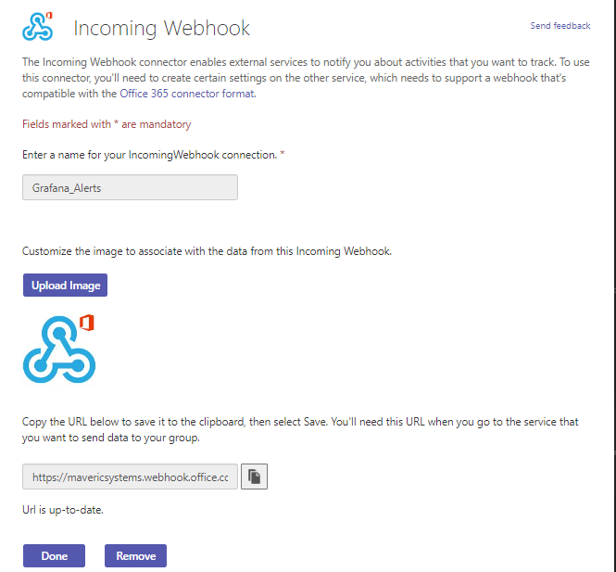
Give the name whatever you want. and then click on “Create”.
After then you will get the URL.
Copy it and click on “Done”.
- Login to your Grafana Dashboard.
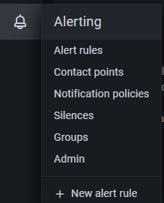
Then go to Alerting section. Refer the Screenshots.

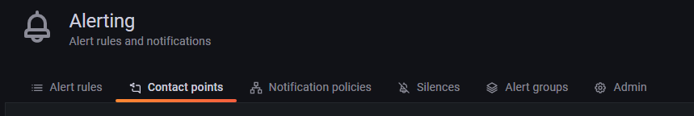
- Go to “Contact Points”. Here only you will be pasting the URL.
- Click on “New Contact Points” 
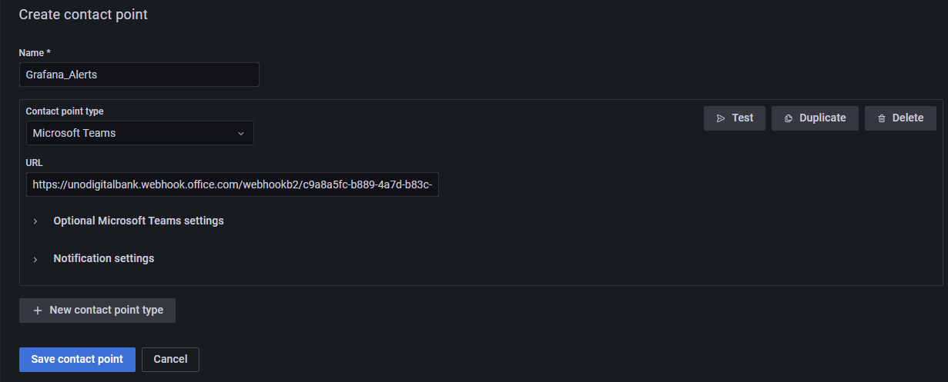
- Fill the Information as above but the URL will be different.
- After that you can TEST it out that if it is working or not.
- If it is Successful, then Save Contact Point.
Now we’ll create the Grafana Teams Alerts.
Note:- You cannot set the alerts on Table. You will not get an option for that.
- We need to figure it out on which Dashboard we have to set an alerts.
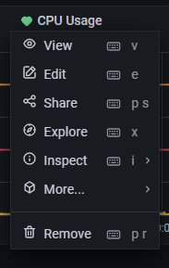
Choose the Dashboard
Hover on the name you will see the arrow jut click on it you will see the drop-down and click on edit.
- When it opens you will see the 3 Option as below.
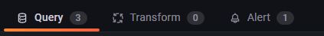
- Click On Alert.
- You will see the below button on the alert page.
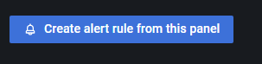
- Click on it and it will redirect to the Actual Alert page where you will create the Rules for the same.
Scenario & use case of rule and Alert.
2 is the limit set in the Graph.
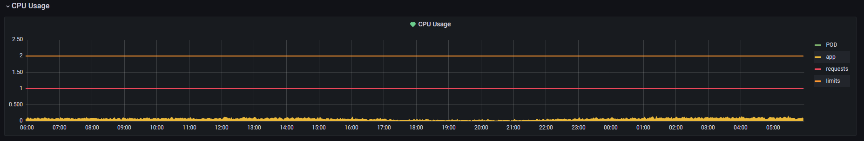
This the graph for the Container named “app” running inside the POD. You can see the name on the right-hand side of the graph.

- We are creating the alerts, if the CPU Usage will rise to the Limit which is set in the graph. Then the POD will crash, and there will be some downtime. For the prevention we are creating the alert so we will get the alert. If the CPU Usage goes up above 90%.
- One more thing we have to make this alert Dynamic.
- Limit is set to 2 as of now. But it may be possible it will increase in future. And then it will be manual task. Same with the app container.
- We will create the “Math Expression”.
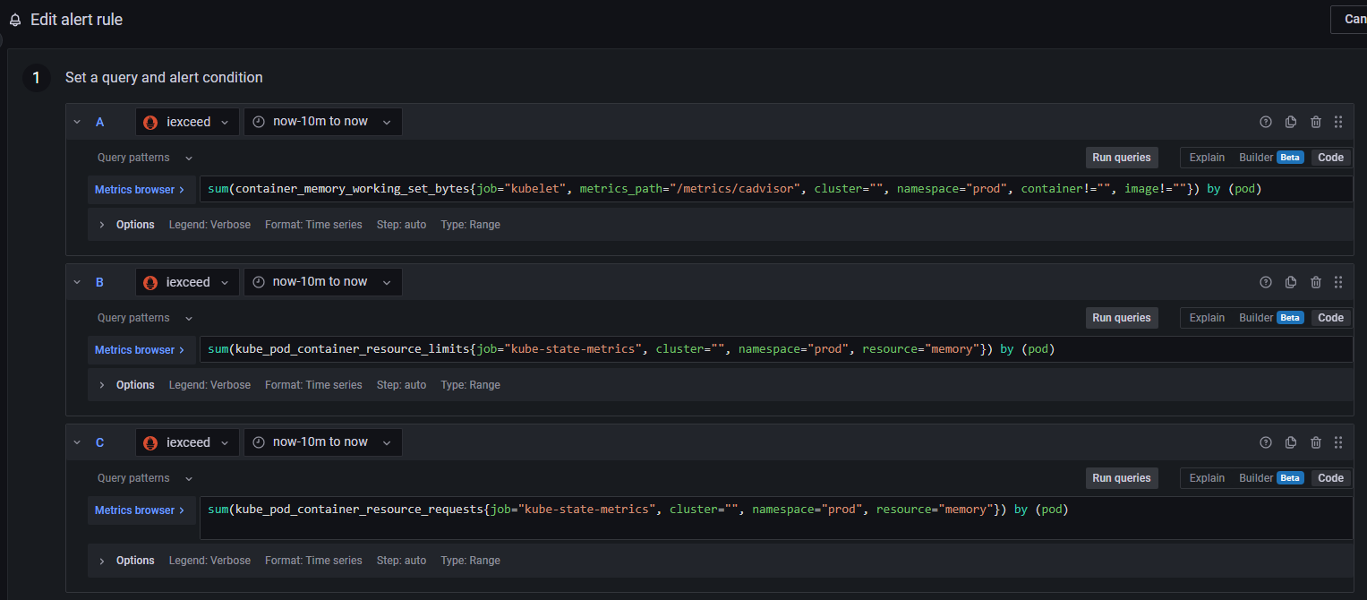
- You will see multiple queries When you click on the below buttion

- You need to figure it out which one is for Container “app” & which one is for “Limit”.
- The 3rd one is “request”, it will not help in this. So just forget it.
- I figured It out with the query itself.
- A one is Container “app” one for that value will change frequently.
- B is the “Limit” one for that value is set as “2”.
- When you come into the Alert Console. Then you can tweak the query as per you requirements.
- Now for creation of Rule & Math Expression.
- We need to assign the values but in Grafana we initialize the variable in a different way. (Refer the below screenshot).
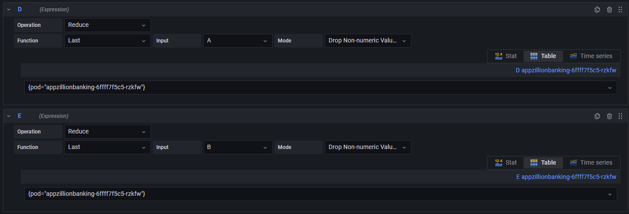
Note:- This is the Expression name. D & E
- D expression:-
  - Reduce is an operation in that you will find many more function.
  - Function we have used Last because we want the last value of the assigned value which is “A”, in this case.
  - Input is “A”, and we are assigning the “A” value to “D”.
  - Mode is “Drop Non-Numeric Value”. You can find some more option in the drop-down.
- E expression:-
  - Reduce is an operation in that you will find many more function.
  - Function we have used Last because we want the last value of the assigned value which is “B”, in this case.
  - Input is “B”, and we are assigning the “B” value to “E”.
  - Mode is “Drop Non-Numeric Value”. You can find some more option in the drop-down.
- Now the “A” denotes to “D”.
- And “B” denotes to “E”.

Below is the Math Expression in which we have to do some maths.

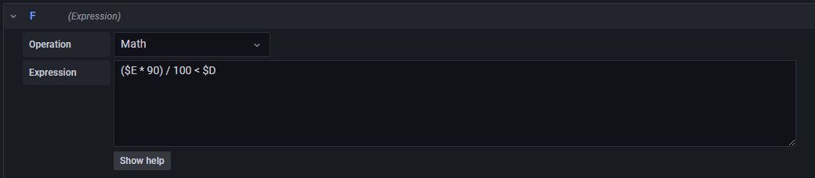
- F Expression:-
  - Operation will be math only.
  - Expression will be the rule which we need to create. ($E * 90) / 100 < $D.
- I’ll simplify the expression for you.
  - $E is limit in which the value is 2. I showed it to you when creating the expression.
  - 90 is the % which we have to take.
  - We need to take out the 90% of $E. The Ans will be 180.
  - Now we will divide 180 / 100. The Ans will be 1.80.
  - After that we can just check with the $D value which is earlier $A and contains the Container (app) value.
  - 1.80 is less than the value of $D. If true, then you will not get the alerts. But if false, then you will receive the in the same channel which you have created.
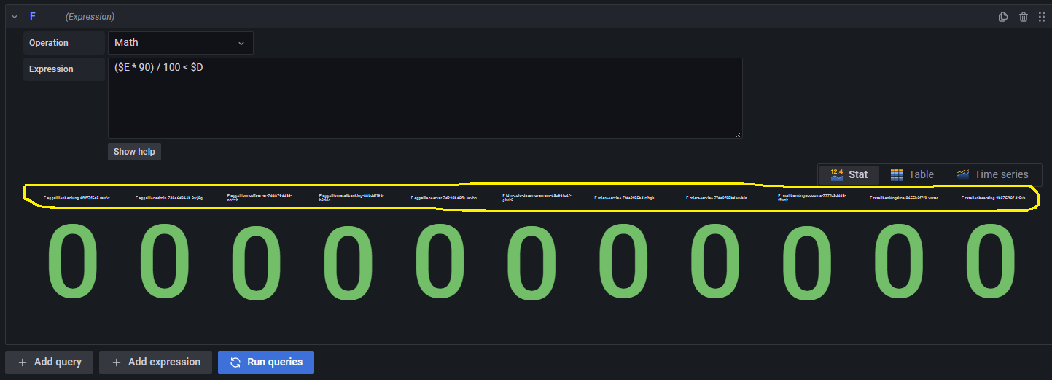
If the value is mixed like 0 & 1 both then for the respective pod container is running above 90%
When you click on the “Run Queries” then you can see the result in 0 or 1 format.

This is the POD’s in which the “app” containers are running. You can see the 11 pods above. Below is the list of all the 11 pods. (Refer the Screenshot below.)
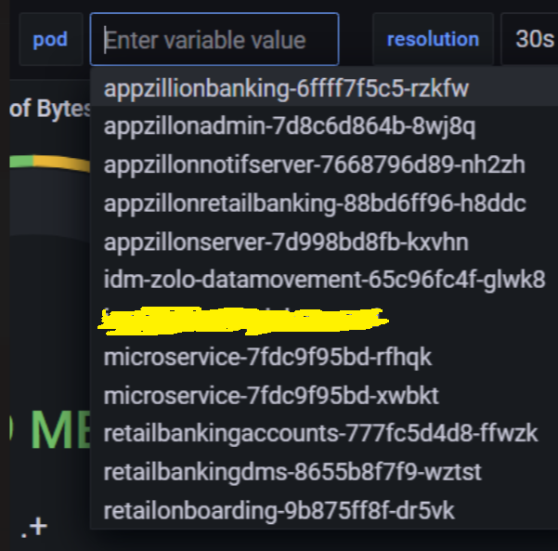
Some More examples of the math Expression. (Refer the below screenshots).
Below we have set the % as 50, that’s why some of the POD’s are given the value as 1.
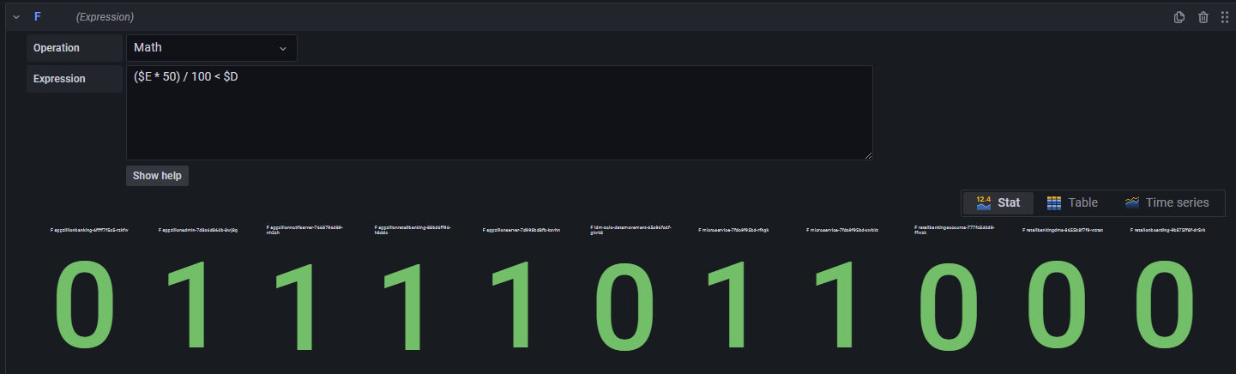

Below we have set the % as 80, that’s why some of the POD’s are given the value as 1.
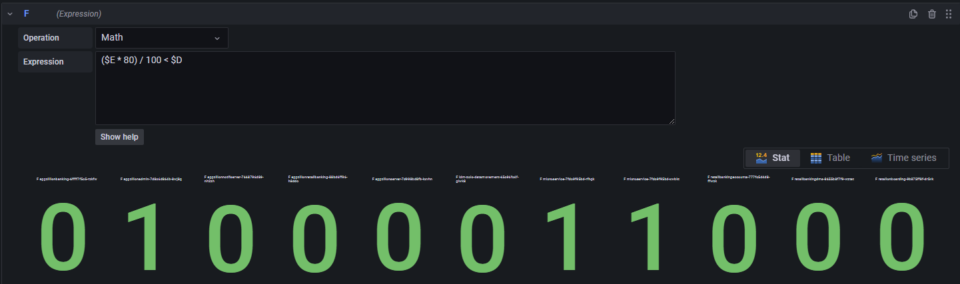
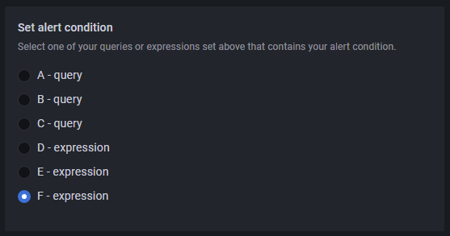
F-Expression is the Math Expression in our case. So, we will be running the last one it-self. Their will be some cased when you need to change the hierarchy for the same. But by default, it will at the last one only.

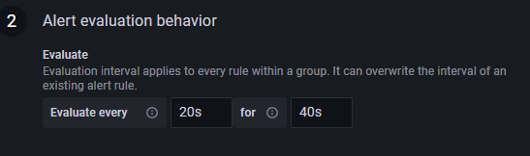
2. And it will wait till 40 seconds, if then also the value is above 90% then it will change the status to “Alerting”. And then after couple of seconds you will receive the alert in the Channel.
- This means it will Evaluate you rule in every 20 seconds and if it found that the value is above 90% then it will change the status as “Pending”.

- Note:- Ideally it should be set as 1 minute and 4 Minute.

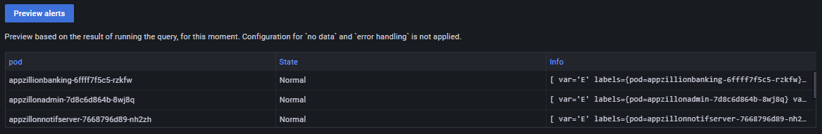
- If you click on the “Preview Alert” The you can see the all the POD’s and the State of the POD’s. As of now it is normal, but it might be in Alerting or Pending state.

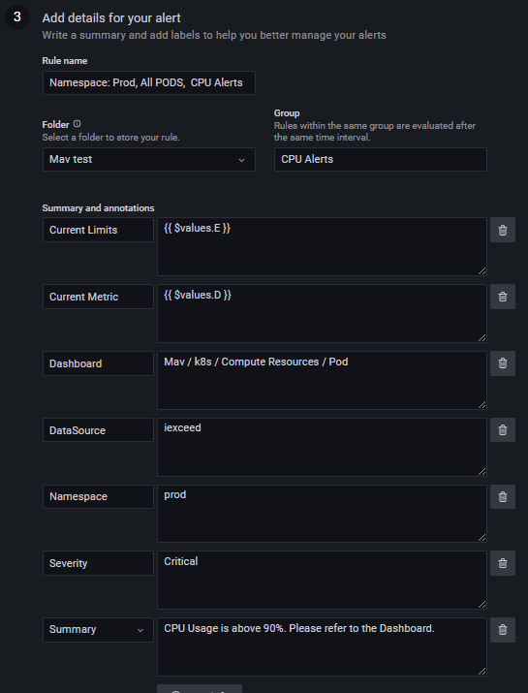
These details are helpful to the person who is monitoring the Alerts in the channel.
These details will reflect in the Grafana Alerts.
You can add more details if required.
Current limit & Current Metric is fetched from the Expression which we have created.
You can give the Rule name which that yo can identify the Rule.
You can give the Folder name and the rule will show in the folder itself. & group name you can give anything.

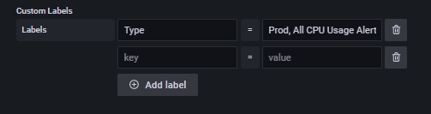
Note:- This Custom Labels is mandatory to create. And it must be different from others. As in unique value should be there.
- You can give as many Labels as you want. But it has to be unique.
- Type value can be the same, but the right-hand side value should be unique.
- If the value is same you may not receive the alert in your Teams Channel.
Below is the reason why it should be unique.
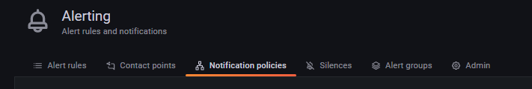
We need to go to Notification Policies.

- And then you need to create the Notification Policies for all the rule you have in alerts rules section.
(Below is the 6 Notification Policies)
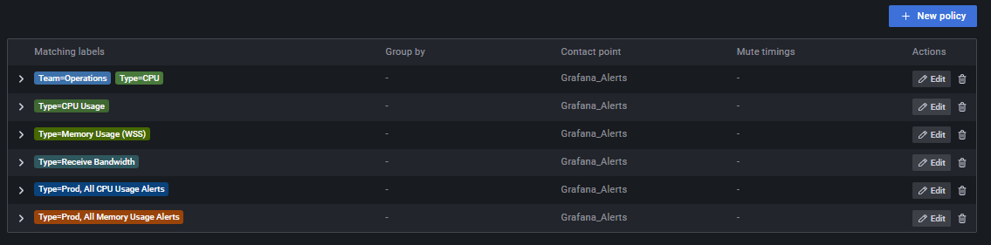
- If the matching labels is the same with others, then how will the rule understand which label is for which rule. And it might happen that you will receive the wrong Alerts.
- I have 6 Notification Policies for 6 rules which I have in Alerts Section.
(Below are the 6 rules which I have.)
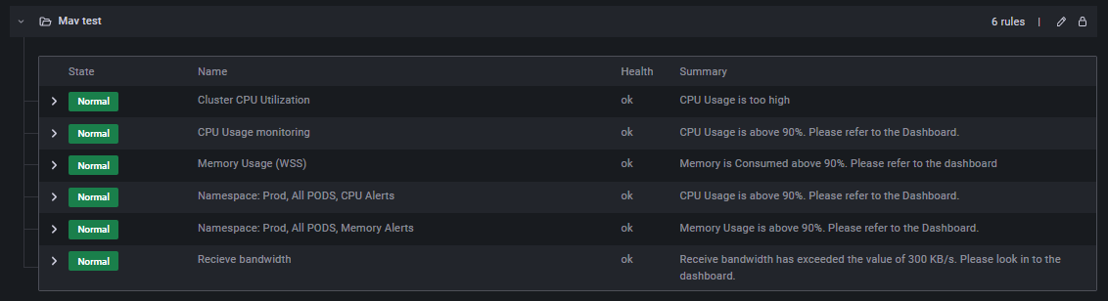
How we can create the Notification policy
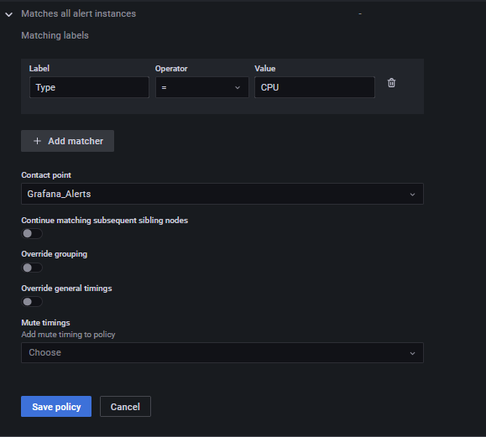
You just need to click on “New Policy”.
Then you have to type the Matching labels which you have created in the Rule. Just copy paste it here.
And select the “Contact Point”. In our case it’s “Grafana_Alerts”.
Then Save Policy.
Now you are good to go. With the Microsoft Teams Alerts

